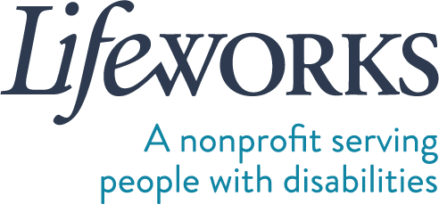

EMPLOYMENT PAPERWORK REQUEST FORM

Within 1 business day of receiving this form, Lifeworks will send the employee their employment paperwork via Paylocity.

PARTICIPANT FIRST (LEGAL) NAME  Click or tap here to enter text. | PARTICIPANT LAST (LEGAL) NAME  Click or tap here to enter text.
PARTICIPANT PROGRAM - FMS
☐ CDCS ☐ CSG
PARTICIPANT PROGRAM – 245D Basic
☐ Respite ☐ Homemaker ☐ Individualized Home Support ☐ Night Supervision
PARTICIPANT PROGRAM - PCA
☐ PCA Choice
MANAGING PARTY LEGAL NAME (signer of the employee’s I9)
Click or tap here to enter text.
MANAGING PARTY EMAIL  Click or tap here to enter text. | MANAGING PARTY PHONE NUMBER  Click or tap here to enter text.
EMPLOYEE FIRST (LEGAL) NAME  Click or tap here to enter text. | EMPLOYEE LAST (LEGAL) NAME  Click or tap here to enter text.
EMPLOYEE EMAIL  Click or tap here to enter text. | EMPLOYEE PHONE NUMBER  Click or tap here to enter text.
EMPLOYEE DATE OF BIRTH Age pertains to eligibility to work in specific programs
Click or tap to enter a date.

Please e-mail completed form to: GetHired@lifeworks.org, fax to: #651-454-2773, or drop it off at: 6636 Cedar Ave South, Suite 250, Richfield, MN 55423.

Please have employee reach out to Lifeworks at GetHired@lifeworks.org with questions pertaining to the employment paperwork process.

Thank you!

Self-Directed Hiring
Lifeworks Services, Inc.
p: 651-454-2732 | f: 651-454-2773

LIFEWORKS SERVICES ∙ 6636 Cedar Ave South, Suite 250, Richfield, MN 55423 ∙ lifeworks.org Updated 5/6/2024

